Considering Equality Impact Assessment when preparing new and amending existing documents

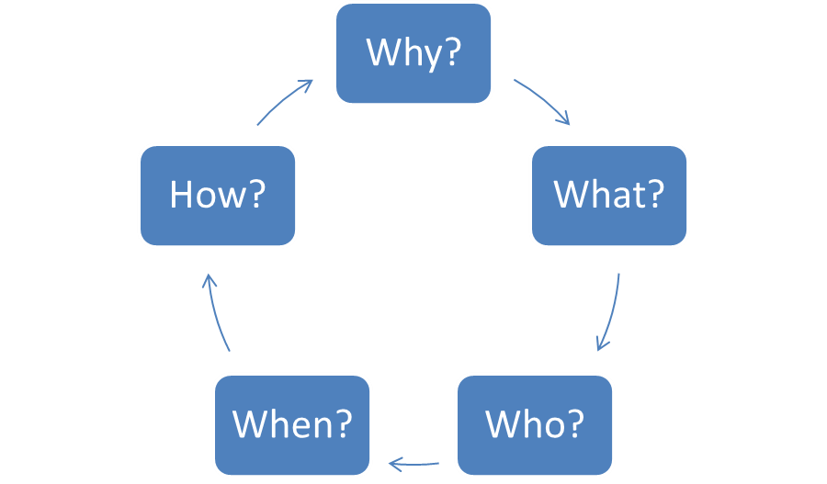

Purpose
This guidance is intended to inform staff of the process that should be followed when a new document is produced or an existing document is amended or revised.
Public Sector Equality Duty
Under the Equality Act 2010 and the Equality Act 2010 (Specific Duties) (Scotland) Regulations 2012 the University, in the exercise of its functions, is required to comply with a public sector equality duty (PSED) consisting of a general duty supported by specific duties and must have due regard to the need to:
- Eliminate unlawful discrimination, harassment and victimisation and other conduct prohibited by the Equality Act 2010;
- Advance equality of opportunity between people from different groups, considering the need to:
- Remove or minimise disadvantages suffered by people due to their protected characteristics;
- Meet the needs of people with protected characteristics;
- Encourage people with protected characteristics to participate in public life or in other activities where their participation is low.
- Foster good relations between people from different groups, tackling prejudice and promoting understanding between people from different groups.
In order to demonstrate due regard, the University must consider the three needs of its general duty:
- Developing, evaluating and reviewing policies;
- Designing, delivering and evaluating services, including education provision;
- Commissioning and procuring services from others.

How to prepare an Equality Impact Assessment

The University is required to evaluate policies (and other documents) by performing an Equality Impact Assessment (EIA) for each one. There are two types of EIA that can be carried out: a comprehensive EIA (CEIA) and a quick EIA (QEIA).

Comprehensive EIA
- Must be carried out for all new policies;
- Must be carried out when reviewing all existing policies if a Quick Impact Assessment shows that any protected characteristic may be affected.
Quick EIA
- Carried out when revising or making minor amendments to all existing documents.

Steps to take | Action to be completed
Step 1 | Select the relevant EIA form from the two available (details above).
Step 2 | Consider and complete the EIA form alongside writing or amending the document.
Step 3 | Consider new and existing data when answering all the questions. Examples of existing data can be found near the end of this document.
Step 4 | Consult with Lead Voices if the EIA shows that any of the protected characteristic groups will have different experiences, issues or needs in relation to this document.
Step 5 | Where relevant ensure that your line manager has signed off the document and EIA.
Step 6 | Attach EIA to the back of the document.
Step 7 | Send to Academic Registry asking that document is sent to the JLG for consultation,  then to the relevant committee for approval, secretariat@abertay.ac.uk.
Step 8 | Document can be published once approval received.

Resources

Internal people & resources

Lead Voices
Sharon Jeffrey, Occupational Health Advisor, s.jeffrey@abertay.ac.uk
Teaching & Learning Enhancement Team: https://intranet.abertay.ac.uk/services/nettle/contactus/
Learner Development Advisors (located in Student Services): https://intranet.abertay.ac.uk/services/studentservices/learner-development/
David Cameron, Mental Health Advisor (Student), mentalhealth@abertay.ac.uk

Qlikview (Student Number Reporting) https://intranet.abertay.ac.uk/services/planningoffice/studentnumberreportingqlikview/
Athena SWAN Charter Bronze Award (Institutional)
https://www.abertay.ac.uk/discover/the-university/governance-and-management/equalityanddiversity/charter-marks/athena-swan/
Race Equality Charter Bronze Award
https://www.abertay.ac.uk/discover/the-university/governance-and-management/equalityanddiversity/charter-marks/race-equality-charter/

External resources

University Equality & Diversity Protected Groups external page. This page contains useful links to both local and national external groups.
https://www.abertay.ac.uk/discover/the-university/governance-and-management/equalityanddiversity/protected-groups/

N.B. JLG consultation not required for student-facing policies

